**Understanding the Structure Of A Vagrantfile**



**What is Vagrant?**

**Vagrant** is an open-source tool that simplifies the creation, configuration, and management of virtual development environments. It acts as a layer between virtualization tools (such as VirtualBox, Docker, or Hyper-V) and the virtual machines (VMs) you work with. [With Vagrant, you can easily set up consistent development environments across different platforms, making it a valuable tool for developers and system administrators](https://en.wikipedia.org/wiki/Vagrant_%28software%29).

**What is a Vagrantfile?**

A **Vagrantfile** is a configuration file written in Ruby and used by Vagrant to define and manage virtual machine (VM) environments. It allows you to specify various settings or configurations for your VMs, such as the base box, network configuration, and provisioning scripts. The Vagrantfile is the primary configuration location for any Vagrant development environment.

**Purpose of a Vagrantfile**

- A Vagrantfile describes the type of machine required for a project and how to configure and provision these machines.

- Each project typically has its own Vagrantfile, committed to version control, allowing other developers to set up the environment consistently.

- Every configuration option needed is placed inside this file.

**Vagrantfile Settings and Configurations**

Some common settings and configurations in a Vagrantfile:

**1. Base Box**:

A **base box** is a minimal VM image that serves as a starting point for creating Vagrant environments. It contains only essential components (e.g., package manager, SSH) and is not repackaged from an existing environment. Examples include Ubuntu base boxes like "bionic64" provided by Vagrant.

**2. Network Configuration**:

- Vagrant provides high-level networking options for VMs:

- **Forwarded Ports**: Map ports from the guest VM to the host machine.

- **Private Networks**: Create private networks (e.g., DHCP-assigned IP addresses) within the VM.

- These abstractions work across different providers (e.g., VirtualBox, VMware).

**3. Provisioning Scripts**:

- a set of instructions that configures and sets up your virtual machine (VM) automatically. It ensures that your VM is ready for development or testing without manual intervention. Here are the key points:

- **Shell Provisioner**: is the most common type of provisioning in Vagrant. It uploads and executes shell scripts within the guest VM.

- Ideal for quick setup or users new to Vagrant.

- Specify scripts using `inline` or `path` options in your Vagrantfile. The `inline` and `path` options are used with the **\*\*Shell provisioner\*\*** to specify how provisioning scripts are executed:

- **`inline`**:

- When you use `inline`, you provide the actual shell commands directly within your Vagrantfile.

- Example:

```ruby

config.vm.provision "shell", inline: "echo Hello, World"

```

- In this case, the VM executes the `echo Hello, World` command during provisioning.

- **`path`**:

- With `path`, you reference an external shell script file located on your host machine.

- Example:

```ruby

config.vm.provision "shell", path: "bootstrap.sh"

```

- Here, `bootstrap.sh` is a separate shell script in the same directory as your Vagrantfile.

These options are chosen to best suit your needs based on simplicity and organization.

**Components of a Vagrantfile**

Here's a breakdown of its components:

1. **Basic Vagrantfile Example**

- **Ruby Syntax**: Vagrantfiles use Ruby syntax, but you don't need extensive Ruby knowledge. Most modifications involve simple variable assignments. Just like other programming languages, you can include a comment in a Vagrantfile using the hash symbol (#).

- Here's a minimal Vagrantfile that specifies the base box, network, provider, memory and cpu. It also provisions a shell script to install and start an nginx web server:

```ruby

Vagrant.configure("2") do |config|

config.vm.box = "ubuntu/bionic64"

config.vm.network "private_network", ip: "192.168.33.10"

config.vm.provider "virtualbox" do |vb|

vb.memory = "1024"

vb.cpus = 2

end

config.vm.provision "shell", inline: <<-SHELL

sudo apt-get update

sudo apt-get install -y nginx

sudo ufw allow "Nginx HTTP"

sudo systemctl enable nginx

sudo systemctl start nginx

SHELL

end

```

In this example:

- `Vagrant.configure("2")` specifies the Vagrant version (usually "2" which is the current one and works with Vagrant 1.1 and up). Vagrant uses API versions for its configuration file to stay backwards compatible.

- `config.vm.box` sets the base box (e.g., Ubuntu 14.04).

- `config.vm.network` defines a private network with a specific IP address.

- `config.vm.provider` configures VM-specific settings (e.g., memory allocation).

- `config.vm.provision` configures provisioners for your virtual machine (VM). Provisioners automatically install and configure software when the VM is created

2. **Vagrant Boxes**

- A **Vagrant box** is a prebaked VM image (similar to an ISO image for creating VMs).

- You can download community boxes from [Vagrant Cloud](https://app.vagrantup.com/boxes/search).

- Customize your box by adding shell scripts (as in the example above) or using configuration management tools (e.g., Chef, Ansible).

3. **The Role of `end` in a Vagrantfile**

- The `end` statements close blocks of configuration within the Vagrantfile.

- For example, the `do |config| ... end` block encapsulates all VM-related settings.

- Proper indentation ensures clarity and readability. Always ensure proper nesting and matching do-end pairs.

- Consequences of missing or not properly indenting `end` statement:

- Ruby interprets the file incorrectly.

- You’ll likely encounter errors during Vagrant commands (e.g., `vagrant up`, `vagrant reload`).

Here's what the Vagrantfile looks like in a text editor:

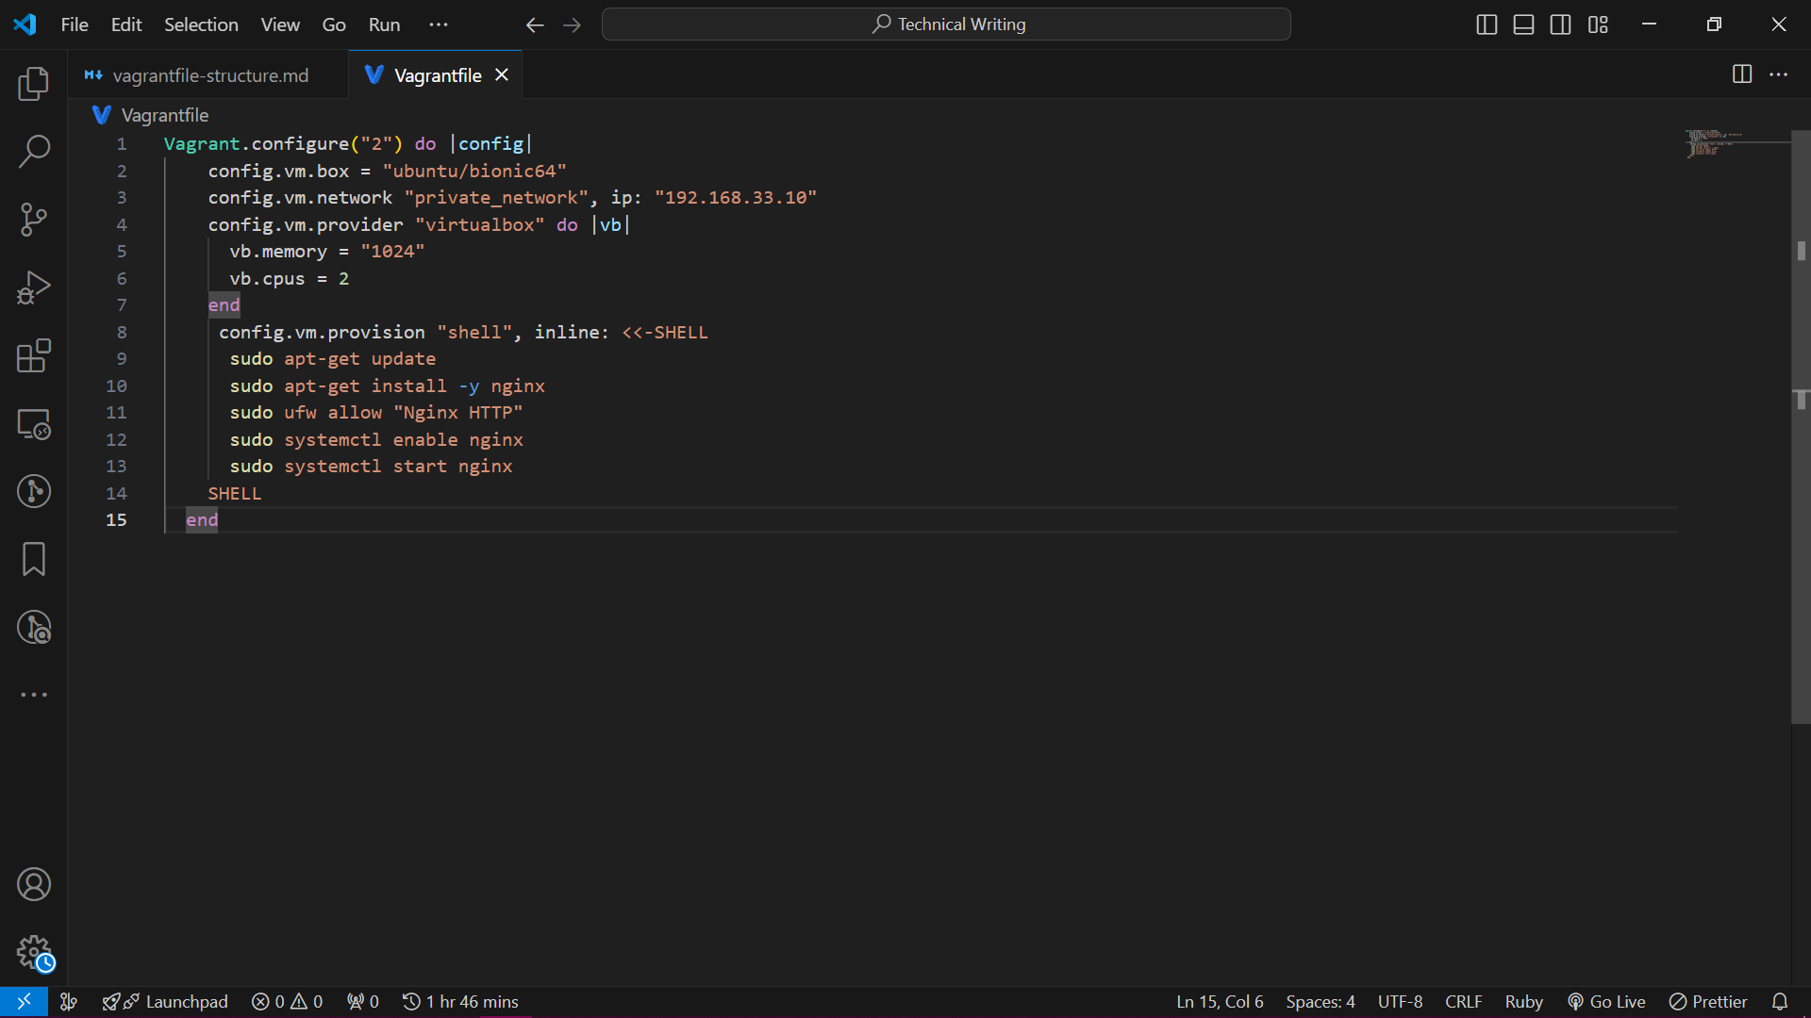

**How to Set Up a Vagrantfile**

Setting up a **Vagrantfile** is pretty straightforward. Below are some steps to create and configure your Vagrant environment:

1. **Install Prerequisites**:

- Install [Vagrant](https://www.vagrantup.com/downloads) on your system.

- Ensure you have [VirtualBox](https://www.virtualbox.org/) (or another supported provider) installed.

2. **Create a Project Directory**:

- Create a new directory for your Vagrant project (e.g., `my-vagrant-project`).

3. **Initialize the Vagrantfile**:

- Open a terminal and navigate to your project directory:

```bash

cd /path/to/my-vagrant-project

```

- Initialize the Vagrant project by running:

```bash

vagrant init

```

- This command creates a basic `Vagrantfile` in your project directory.

4. **Edit the Vagrantfile**:

- Open the `Vagrantfile` using a text editor (e.g., VS Code, Notepad++).

- Customize the configuration based on your needs:

- Set the base box (e.g., Ubuntu, CentOS) using `config.vm.box`.

- Configure network settings (e.g., private network IP) using `config.vm.network`.

- Adjust provider-specific settings (e.g., memory, CPU) if necessary.

5. **Start the VM**:

- Run the following command to create and provision the VM:

```bash

vagrant up

```

- Vagrant will download the base box and set up the VM according to your configuration.

6. **Access the VM**:

- To log in to the VM via SSH, use:

```bash

vagrant ssh

```

7. **Share Files**:

- The project directory is automatically shared with the VM. Any files in your project folder are accessible within the VM.

8. **Additional Commands**:

- Explore other useful Vagrant commands like `vagrant halt` (stop VM), `vagrant destroy` (remove VM), and `vagrant reload` (restart VM).

**Use Cases for Vagrant**

**Vagrant** is a powerful tool with various use cases. Some common scenarios where it shines are:

1. **Development Environments**:

- **Consistent Dev Environments**: Vagrant ensures that all team members work in identical development environments. Developers share a common Vagrantfile to ensure identical development environments and avoid discrepancies in software versions or configurations.

- **Quick Setup**: Spin up VMs with predefined configurations (e.g., specific OS, software versions) for development.

2. **Testing and QA**:

- **Automated Testing**: Vagrant simplifies testing by creating isolated VMs for running tests.

- **Integration Testing**: Test software across different environments (e.g., Windows, Linux) using Vagrant VMs.

3. **Learning and Training**:

- **Hands-On Learning**: Students and learners can experiment with various technologies without affecting their main system.

- **Workshops and Tutorials**: Instructors can provide consistent VMs for workshops or online courses.

4. **Infrastructure as Code (IaC)**:

- **IaC Development**: Use Vagrant to prototype infrastructure configurations (e.g., Ansible, Terraform) locally before deploying to the cloud.

- **Playground for Infrastructure as Code (IaC) Tools**: Experiment with tools like Docker, Kubernetes, or Puppet in VMs.

5. **Demos and Presentations**:

- **Portable Demos**: Create VMs with preinstalled software for demos or presentations.

- **Reproducible Scenarios**: Ensure consistent setups during live demos.

6. **Legacy Software Support**:

- **Isolated Environments**: Run legacy applications or outdated software in VMs without polluting your host system.

- **Avoid Dependency Hell**: Keep old libraries or dependencies separate from your main OS.

In summary, the Vagrantfile simplifies VM management and empowers you to create reproducible environments effortlessly.

(We need to link our website in the conclusion and let the reader know we cover this as part of our course outline)